Multiple-choice section

|  |  |  |  |  |  |  |  |  |  |  |  |
| --- | --- | --- | --- | --- | --- | --- | --- | --- | --- | --- | --- |
| Question | 1 | 2 | 3 | 4 | 5 | 6 | 7 | 8 | 9 | 10 | 11 |
| Answer | B | A | B | A | D | D | A | C | B | C | C |

Question 1 [2.1]

B

20 × 1 = 20

20 × 2 = 40

20 × 3 = 60

20 × 4 = 80

Question 2 [2.2]

A

The first five prime numbers are 2, 3, 5, 7, 11

0, 1, 4 and 9 are not prime numbers.

Question 3 [2.4]

B

0 < 10

Question 4 [2.5]

A

6 – 4 + 5 = 7

Question 5 [2.1]

D

40 doesn’t divide evenly into 3, 6, or 9.

40 is divisible by 2.

Question 6 [2.4]

D

2, 3, 7, 11 is the only set of numbers in ascending order.

Set A and C are in no clear order. Set B is in descending order.

Question 7 [2.6]

A

8 – (-4) = 8 + 4 = 12

Question 8 [2.7]

C

-12 – (-2) – (+2) = -12 + 2 – 2

Question 9 [2.3]

B

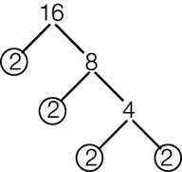

2 × 2 × 2 × 2

Question 10 [2.2]

C

5, 23 and 19 are prime numbers.

30 is composite.

The factors of 30 are 1, 2, 3, 5, 6, 10, 15, 30

Question 11 [2.1]

C

8: 1, 2, 4, 8

12: 1, 2, 3, 4, 6, 12

HCF is 4.

Multiple-choice total marks: 11

Short answer section

Question 12 3 marks [2.1]

(a) A number is divisible by 2 if the last digit is an even number.

(b) A number is divisible by 5 if the last digit is 0 or 5.

(c) A number is divisible by 3 if the sum of the digits is divisible by 3.

Question 13 3 marks [2.1]

Multiples of 6: 6, 12, 18, 24, 30

Multiplies of 8: 8, 16, 24, 32, 40

LCM of 6 and 8 = 24

Question 14 3 marks [2.1]

12 and 16

12: 1, 2, 3, 4, 6, 12

16: 1, 2, 4, 8, 16

HCF: 4

Question 15 2 marks [2.1]

|  |  |  |
| --- | --- | --- |
| **÷ 2** | **÷ 5** | **÷10** |
| 15 not even  Do not shade 15 | Ends in 0 or 5, so is ÷ 5 | Does not end in 0, so is NOT ÷ 10 |
| 20 even, so ÷ 2 | Ends in 0 or 5, so is ÷ 5 | Ends in 0, so is ÷ 10 |
| 18 even, so ÷ 2 | Does not end in 0 or 5, so is NOT ÷ 5  Do not colour 18 | Does not end in 0, so is NOT ÷ 10 |
| 90 even, so ÷ 2 | Ends in 0 or 5, so is ÷ 521 is ÷ 3, so 2892 is ÷ 3 | Ends in 0, so is ÷ 10 |

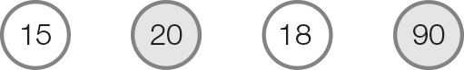

Question 16 1 mark [2.2]

2, 3, 5, 7, 11

Question 17 3 marks [2.2]

6 and 27 are not co-prime because their HCF is 3.

Factors of 6: 1, 2, 3, 6

Factors of 27: 1, 3, 9, 27

Common factors are 1 and 3

Question 18 2 marks [2.2]

45, 46

28, ~~29~~, 30

16, ~~17~~, 18

1, ~~2~~, ~~3~~, 4

Question 19 2 marks [2.3]

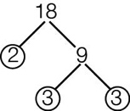

18 = 2 × 3 × 3

= 2 × 32

Question 20 2 marks [2.3]

22 × 32

= 2 × 2 × 3 × 3

= 4 × 9

= 36

Question 21 2 marks [2.4]

(a) 8 m above the ground = + 8 m

(b) 5 °C below zero = -5 °C

Question 22 3 marks [2.4]

(a) +10 > -9

(b) -8 < -4

(c) 0 > -5

Question 23 2 marks [2.4]

-4, -2, 0, 2, 4, 14

Question 24 2 marks [2.4]

20, 5, -5, -15, -20, -25

Question 25 3 marks [2.4]

(a) 134 + 9 = 143 m

(b) 141 – 49 = 92 m

Question 26 2 marks [2.7]

-10 – (-4) + -1 + 3

= -10 + 4 -1 + 3

= -10 + 3 + 3

= -10 + 6 = -4

Question 27 3 marks [2.5]

(a) 2 + 19 = 21 (b) -5 + 30 = 25 (c) 27 – 17 = 10

Question 28 4 marks [2.5]

(a) -4 + 3 + 2  
= -1 + 2  
= 1  
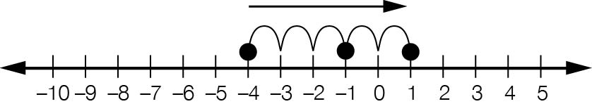

(b) 19 – 15 – 11  
= 4 – 11  
= -7



Question 29 2 marks [2.6]

(a) -2 + 5 + (-3)

(b) -2 + 5 – 3 = 0 Julia ended up where she started

Question 30 2 marks [2.7]

(a) 30 – (-10) = 30 + 10

True: two like signs means add.

(b) 15 + (-5) = 15 + 5

False: two unlike signs means subtract.

Question 31 2 marks [2.7]

|  |  |
| --- | --- |
| (a) Recall: - (-) = +  -(-0) = 0 | (b) Recall: + (-) = - +(-12) = -12 |
| (c) Recall: - (+) = - -(+8) = -8 | (d) Recall: + (+) = + +(+42) = 42 |

Question 32 2 marks [2.6]

-8 + 10 – 9  
= 2 – 9  
= -7

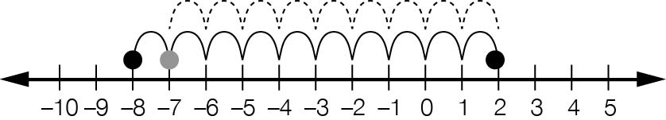

Question 33 2 marks [2.6]

Card B: 9 + -3 = 6

Short answer total: 52

Extended answer section

Question 34 5 marks [2.7]

(a) -57 °C

(b) August

(c) December

(d) -61 – -28  
= -61 + 28   
= 33 °C

Extended answer total: 5

TOTAL test marks: 68